Practical 7

Title / Aim :- To perform the events handling in JavaScript
a. Access and manipulate form elements using JavaScript
b. validate user input
c. use various form events case study:- create the following html form and use required js and events in a given form.
small clinic want to help receptionist to complete daily tasks task management web application using html, css and js and dom also give code to perform this
Software/Tools Required: VS Code , Web Browser
Experiment program code:
Index.html

<html>
<head>
<title>To-Do List</title>

<style>

body {
font-family: Arial, sans-serif;
background-color: #f3f6fb;
text-align: center;
padding: 40px;
}

h2 {
color: #1a5cff;
font-size: 28px;
margin-bottom: 20px;
}

h3 {
color: #555;
font-size: 16px;
font-weight: normal;
margin-bottom: 25px;
}

input {
padding: 10px;
font-size: 15px;
border: 1px solid #bbb;
border-radius: 6px;
width: 230px;
outline: none;
}

input:focus {
border-color: #1a5cff;
box-shadow: 0 0 4px rgba(26, 92, 255, 0.25);
}

/* Add button */
button {
padding: 9px 16px;
font-size: 15px;
background-color: #1a5cff;
color: white;
border: none;
border-radius: 6px;
cursor: pointer;
margin-left: 5px;
}

button:hover {
background-color: #0d3fb0;
}

/* List */
ul {
list-style: none;
padding: 0;
max-width: 420px;
margin: 25px auto 0;
}

/* Individual task */
li {
background-color: white;
border: 1px solid #e0e4ea;
border-radius: 10px;
padding: 12px 14px;
margin-top: 10px;

display: flex;
justify-content: space-between;
align-items: center;

box-shadow: 0 3px 8px rgba(0, 0, 0, 0.06);

transition: 0.2s;
}

/* Hover effect */
li:hover {
transform: translateY(-2px);
box-shadow: 0 5px 12px rgba(0, 0, 0, 0.1);
}

/* Checkbox */
li input[type="checkbox"] {
width: 17px;
height: 17px;
margin: 0 10px 0 0;
cursor: pointer;
accent-color: #1a5cff;
}

/* Task text */
li span {
flex: 1;
text-align: left;

font-family: "Segoe UI", sans-serif;
font-size: 16px;
font-weight: 500;
color: #263238;

padding-left: 5px;

transition: 0.2s;
}

/* Completed task */
li span.completed {
text-decoration: line-through;
color: #999;
}

/* Edit and Delete buttons */
li button {
padding: 6px 11px;
font-size: 13px;
margin-left: 6px;
border-radius: 5px;
}

/* Edit button */
li button:first-of-type {
background-color: #f59e0b;
}

li button:first-of-type:hover {
background-color: #d97706;
}

/* Delete button */
li button:last-of-type {
background-color: #ef4444;
}

li button:last-of-type:hover {
background-color: #dc2626;
}

/* Count */
#count {
margin-top: 20px;
font-size: 15px;
color: #555;
font-weight: 500;
}

</style>
</head>

<body>

<h2>My To-Do List</h2>

<h3>Sanvi Wadhankar 24070521191</h3>

<input
type="text"
id="taskInput"
placeholder="Enter a task"
>

<button onclick="addTask()">Add</button>

<ul id="taskList"></ul>

<p id="count">Total items: 0</p>

<script>

// Update the count of items using DOM
function updateCount() {

var items =
document.getElementById("taskList")
.children.length;

document.getElementById("count").innerHTML =
"Total items: " + items;
}

// Add a new task
function addTask() {

var input =
document.getElementById("taskInput");

var taskText =
input.value;

if (taskText == "") {

alert("Please enter a task!");

return;
}

// Create list item
var li =
document.createElement("li");

// Create checkbox
var checkbox =
document.createElement("input");

checkbox.type = "checkbox";

// Create span to hold task text
var span =
document.createElement("span");

span.innerHTML =
taskText;

// When checkbox is clicked
checkbox.onclick = function () {

if (checkbox.checked) {

// Add completed class
span.classList.add("completed");

}

else {

// Remove completed class
span.classList.remove("completed");

}

};

// Create Edit button
var editBtn =
document.createElement("button");

editBtn.innerHTML =
"Edit";

editBtn.onclick = function () {

editTask(span);

};

// Create Delete button
var deleteBtn =
document.createElement("button");

deleteBtn.innerHTML =
"Delete";

deleteBtn.onclick = function () {

deleteTask(li);

};

// Append everything to list item

li.appendChild(checkbox);

li.appendChild(span);

li.appendChild(editBtn);

li.appendChild(deleteBtn);

// Add list item to the list

document
.getElementById("taskList")
.appendChild(li);

input.value = "";

updateCount();

}

// Edit a task
function editTask(span) {

var newText =
prompt(
"Edit task:",
span.innerHTML
);
if (
newText !== null &&
newText !== ""
) {
span.innerHTML =
newText;
}
}
// Delete a task
function deleteTask(li) {

li.remove();
updateCount();
}
</script>
</body>
</html>
Output:-
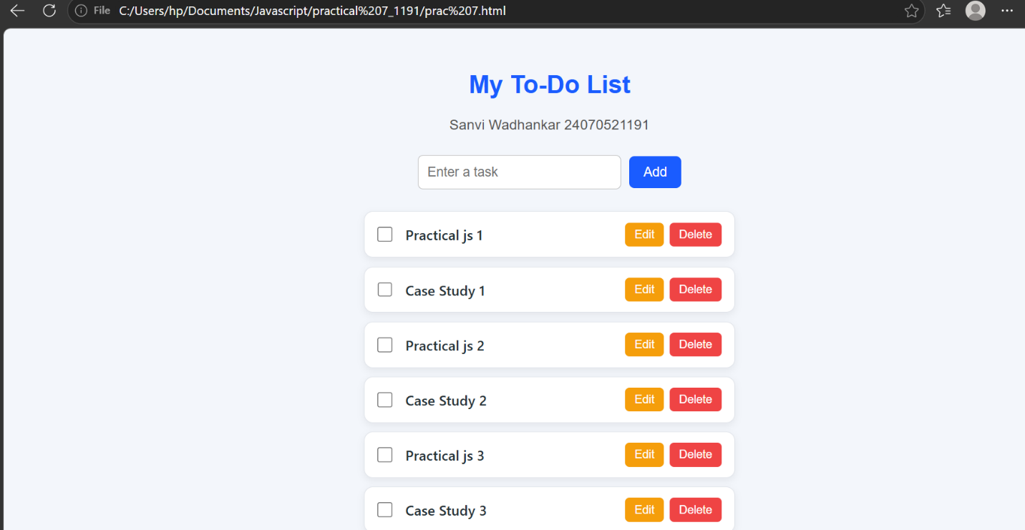

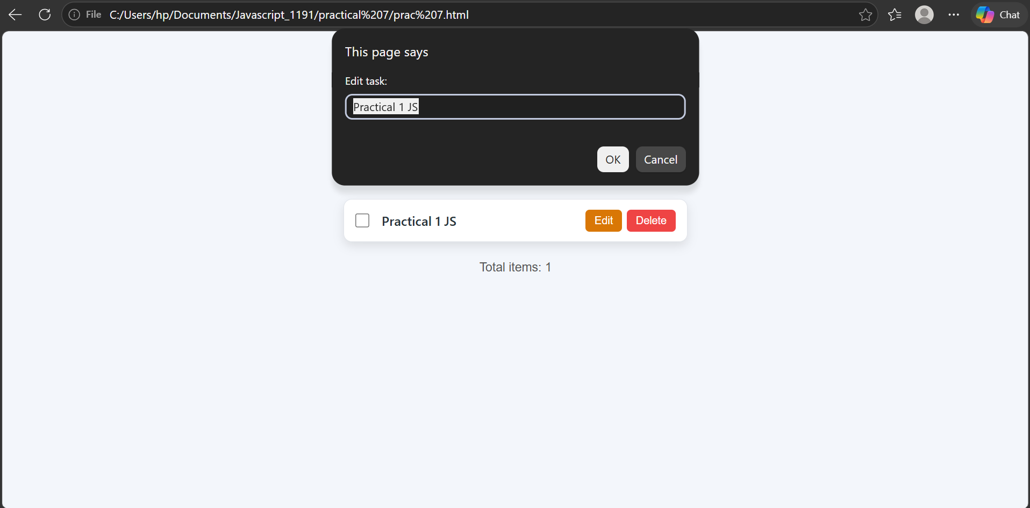
Case Study 7
Aim:- To perform the events handling in JavaScript
a. Access and manipulate form elements using JavaScript
b. validate user input
c. use various form events case study:- create the following html form and use required js and events in a given form.
small clinic want to help receptionist to complete daily tasks task management web application using html, css and js and dom also give code to perform this

Software/Tools Required: VS Code , Web Browser
Case Study Code:-

<!DOCTYPE html>
<html>

<head>

<title>Clinic Receptionist Task Manager</title>

<style>

* {
box-sizing: border-box;
}

body {
font-family: Arial, sans-serif;
background-color: #f3f6fb;
margin: 0;
padding: 30px;
}

.container {
max-width: 850px;
margin: auto;
}

/* Heading */

h1 {
text-align: center;
color: #1a5cff;
margin-bottom: 5px;
}

.subtitle {
text-align: center;
color: #666;
margin-bottom: 25px;
}

/* Form */

.form-box {
background-color: white;
padding: 25px;
border-radius: 12px;
box-shadow: 0 4px 12px rgba(0,0,0,0.08);
margin-bottom: 25px;
}

.form-box h2 {
color: #333;
margin-top: 0;
}

label {
display: block;
margin-top: 15px;
margin-bottom: 6px;
font-weight: bold;
color: #444;
}

input,
select,
textarea {
width: 100%;
padding: 10px;
border: 1px solid #bbb;
border-radius: 6px;
font-size: 15px;
outline: none;
}

input:focus,
select:focus,
textarea:focus {
border-color: #1a5cff;
box-shadow: 0 0 4px rgba(26,92,255,0.2);
}

textarea {
resize: vertical;
height: 80px;
}

.error {
color: #e53935;
font-size: 13px;
margin-top: 4px;
}

.success {
color: #2e7d32;
font-size: 14px;
margin-top: 10px;
}

/* Add Task Button */

.add-btn {
margin-top: 20px;
padding: 11px 20px;
background-color: #1a5cff;
color: white;
border: none;
border-radius: 6px;
font-size: 15px;
cursor: pointer;
}

.add-btn:hover {
background-color: #0d3fb0;
}

/* Tasks */

.tasks-box {
background-color: white;
padding: 25px;
border-radius: 12px;
box-shadow: 0 4px 12px rgba(0,0,0,0.08);
}

.tasks-box h2 {
margin-top: 0;
color: #333;
}

#taskList {
list-style: none;
padding: 0;
margin: 0;
}

.task {
display: flex;
align-items: center;
gap: 10px;

background-color: #f8fafc;

border: 1px solid #e0e4ea;

border-radius: 9px;

padding: 14px;

margin-top: 10px;

transition: 0.2s;
}

.task:hover {
box-shadow: 0 4px 10px rgba(0,0,0,0.08);
}

.task-text {
flex: 1;
text-align: left;
}

.task-title {
font-weight: bold;
color: #263238;
}

.task-details {
font-size: 13px;
color: #777;
margin-top: 4px;
}

.completed {
text-decoration: line-through;
color: #999;
}

.task button {
border: none;
padding: 7px 10px;
border-radius: 5px;
cursor: pointer;
color: white;
}

.edit-btn {
background-color: #f59e0b;
}

.edit-btn:hover {
background-color: #d97706;
}

.delete-btn {
background-color: #ef4444;
}

.delete-btn:hover {
background-color: #dc2626;
}

.complete-checkbox {
width: 17px;
height: 17px;
cursor: pointer;
}

#taskCount {
margin-top: 20px;
color: #555;
font-weight: bold;
}

</style>

</head>

<body>

<div class="container">

<h1>Clinic Receptionist Task Manager</h1>
<h3>Sanvi Wadhankar 24070521191</h3>

<p class="subtitle">
Manage daily clinic tasks efficiently
</p>

<!-- =================================
FORM
================================== -->

<div class="form-box">

<h2>Add New Task</h2>

<form id="taskForm">

<!-- Task Name -->

<label for="taskName">
Task Name
</label>

<input
type="text"
id="taskName"
placeholder="Example: Call patient"
>

<div
id="taskError"
class="error">
</div>

<!-- Priority -->

<label for="priority">
Priority
</label>

<select id="priority">

<option value="">
Select Priority
</option>

<option value="High">
High
</option>

<option value="Medium">
Medium
</option>

<option value="Low">
Low
</option>

</select>

<div
id="priorityError"
class="error">
</div>

<!-- Date -->

<label for="taskDate">
Due Date
</label>

<input
type="date"
id="taskDate"
>

<div
id="dateError"
class="error">
</div>

<!-- Description -->

<label for="description">
Description
</label>

<textarea
id="description"
placeholder="Enter task details">
</textarea>

<button
type="submit"
class="add-btn">

Add Task

</button>

<div
id="successMessage"
class="success">
</div>

</form>

</div>

<!-- =================================
TASK LIST
================================== -->

<div class="tasks-box">

<h2>Today's Tasks</h2>

<ul id="taskList"></ul>

<p id="taskCount">
Total Tasks: 0
</p>

</div>

</div>

<script>

// =========================================
// ACCESS FORM ELEMENTS USING DOM
// =========================================

var form =
document.getElementById("taskForm");

var taskName =
document.getElementById("taskName");

var priority =
document.getElementById("priority");

var taskDate =
document.getElementById("taskDate");

var description =
document.getElementById("description");

var taskList =
document.getElementById("taskList");

var taskCount =
document.getElementById("taskCount");

// =========================================
// FORM SUBMIT EVENT
// =========================================

form.addEventListener(
"submit",
function(event) {

// Prevent page reload
event.preventDefault();

// Validate form
if (!validateForm()) {

return;

}

// Create task
createTask();

// Clear form
form.reset();

document.getElementById(
"successMessage"
).innerText =
"Task added successfully!";

// Remove success message
setTimeout(
function() {

document.getElementById(
"successMessage"
).innerText = "";

},
2000
);

}
);

// =========================================
// FORM VALIDATION
// =========================================

function validateForm() {

var valid = true;

// Clear previous errors

document.getElementById(
"taskError"
).innerText = "";

document.getElementById(
"priorityError"
).innerText = "";

document.getElementById(
"dateError"
).innerText = "";

// Validate Task Name

if (taskName.value.trim() === "") {

document.getElementById(
"taskError"
).innerText =
"Please enter a task name.";

valid = false;

}

// Validate Priority

if (priority.value === "") {

document.getElementById(
"priorityError"
).innerText =
"Please select a priority.";

valid = false;

}

// Validate Date

if (taskDate.value === "") {

document.getElementById(
"dateError"
).innerText =
"Please select a due date.";

valid = false;

}

return valid;

}

// =========================================
// CREATE TASK USING DOM
// =========================================

function createTask() {

// Create list item

var li =
document.createElement("li");

li.className =
"task";

// Create checkbox

var checkbox =
document.createElement("input");

checkbox.type =
"checkbox";

checkbox.className =
"complete-checkbox";

// Create task text container

var textContainer =
document.createElement("div");

textContainer.className =
"task-text";

// Create task title

var title =
document.createElement("div");

title.className =
"task-title";

title.innerText =
taskName.value;

// Create task details

var details =
document.createElement("div");

details.className =
"task-details";

details.innerText =
"Priority: " +
priority.value +
" | Due: " +
taskDate.value +
" | " +
description.value;

// Add title and details

textContainer.appendChild(title);

textContainer.appendChild(details);

// =====================================
// EDIT BUTTON
// =====================================

var editButton =
document.createElement("button");

editButton.innerText =
"Edit";

editButton.className =
"edit-btn";

editButton.onclick =
function() {

editTask(title);

};

// =====================================
// DELETE BUTTON
// =====================================

var deleteButton =
document.createElement("button");

deleteButton.innerText =
"Delete";

deleteButton.className =
"delete-btn";

deleteButton.onclick =
function() {

deleteTask(li);

};

// =====================================
// CHECKBOX CHANGE EVENT
// =====================================

checkbox.addEventListener(
"change",
function() {

if (checkbox.checked) {

title.classList.add(
"completed"
);

}

else {

title.classList.remove(
"completed"
);

}

}
);

// =====================================
// ADD ELEMENTS TO LI
// =====================================

li.appendChild(checkbox);

li.appendChild(textContainer);

li.appendChild(editButton);

li.appendChild(deleteButton);

// Add task to list

taskList.appendChild(li);

updateTaskCount();

}

// =========================================
// EDIT TASK
// =========================================

function editTask(title) {

var newTask =
prompt(
"Edit task:",
title.innerText
);

if (
newTask !== null &&
newTask.trim() !== ""
) {
title.innerText =
newTask;
}
}

// =========================================
// DELETE TASK
// =========================================

function deleteTask(li) {
li.remove();

updateTaskCount();

}
// =========================================
// UPDATE TASK COUNT
// =========================================

function updateTaskCount() {
var total =
taskList.children.length;

taskCount.innerText =
"Total Tasks: " + total;

}

// =========================================
// INPUT EVENT
// =========================================

taskName.addEventListener(
"input",
function() {
if (
taskName.value.trim() !== ""
) {

document.getElementById(
"taskError"
).innerText = "";
}
}
);

// =========================================
// FOCUS EVENT
// =========================================

taskName.addEventListener(
"focus",
function() {
taskName.style.backgroundColor =
"#f0f6ff";
}
);

// =========================================
// BLUR EVENT
// =========================================

taskName.addEventListener(
"blur",
function() {
taskName.style.backgroundColor =
"white";
}
);

// =========================================
// CHANGE EVENT
// =========================================

priority.addEventListener(
"change",
function() {

if (priority.value !== "") {
document.getElementById(
"priorityError"
).innerText = "";

}
}
);
</script>
</body>
</html>

Output:-
